 | 12.1.58 Editors - Geometry Nodes Editor - Header - Add Menu - Normals
Table of content
Detailed table of content 1
Add menu - Normals 1
Smooth by Angle 2

Detailed table of content
Detailed table of content
Detailed table of content 1
Add menu - Normals 1
Smooth by Angle 2
Input 2
Mesh 2
Angle 2
Ignore Sharpness 2
Output 2
Geometry 2

Add menu - Normals


The Normals node Smooth by Angle is a Node Group. Node groups differ from the other nodes in the add menu due to being mid level node groups instead of individual low level nodes.
You can enter the node tree by clicking at the icon up right. Tab to leave the node tree. And you can of course also edit the node tree.
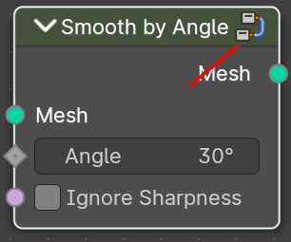
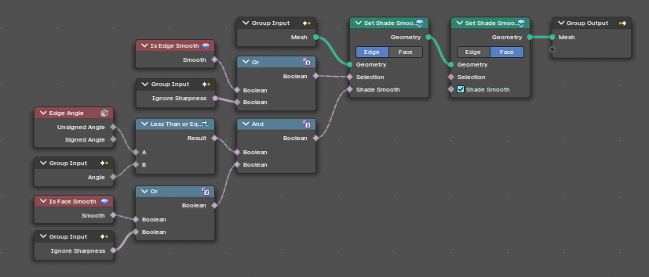

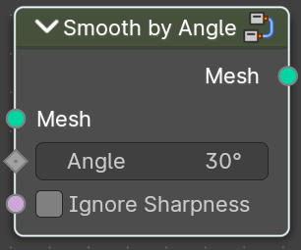
Smooth by Angle
Smoothens or sharpens the mesh edges based on the angle between faces.

Input

Mesh
The input geometry.

Angle
Maximum face angle for smooth edges.

Ignore Sharpness
Ignore the sharpness at edges that are set to sharp.

Output

Geometry
The output geometry.

